Teaching Philosophy
Frankie Zhu
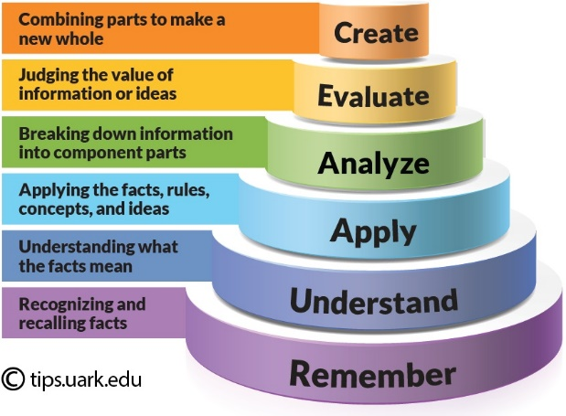
Our students are going to enter a world in which building spacecraft is an attainable skill with a bachelor’s degree and our curriculum should prepare these promising engineers for that reality. I believe the engineering student is best served in the classroom when exchanging face time and knowledge from the lecturer and her peers by flipping the classroom and embracing immersive discussion. Conventional lectures are generally passive but necessary for conveying a large amount of information at a controlled pace. Students begrudgingly involve themselves a large lecture hall, which is naturally not conducive to interaction. Instead in my smaller classrooms, I will employ Bloom’s taxonomy to move upward in the realm of learning, from knowledge to creation, but also move fluidly up and down the learning process to fully clarify concepts [Fig. 1]. My teaching methods focus on maximizing one-on-one interactions, developing supplemental teaching tools, and guided learning.
Figure 1: Bloom's Taxonomy. University of Arkansas
Engagement is key to understanding. The most meaningful interaction will be in discussion sections, in which a small group of students focus on working together to apply their newly acquired knowledge. Students will split into groups no larger than five and must formulate solutions to my carefully crafted problems. I will guide the discussion and constantly walk around to answer questions. Since I cannot talk to every student individually, I hope to disperse this responsibility to other bright students and chime in during critical moments. As a private tutor for Kumon, I taught students in math, science, and English from kindergarten to the college level. I have come to appreciate that explanations are geared toward the level of understanding of the student and there cannot be a “one-size-fits-all” mentality; explanations and situations adapt. As a teaching assistant for a spacecraft mission architecture course, I’ve explained abstract and technical concepts relating to my field in multiple ways. Even though students are at the same level of education, different people form different abstractions while learning. By gathering many minds into one space, we can crowdsource the path to understanding and shed light on commonly misunderstood topics.
The problems in discussion and in assignments will be rooted in real world applications and culminate in a semester-end project. As a former course grader, I have observed that students best grasp complex concepts when the assignment is crafted with a cohesive story, building from simple, shorter problems to larger, more involved problems. By solving a complex problem, basic concepts are applied incrementally and any gaps in understanding are revealed. In the process of solving complex concepts repetitively, students ingrain fundamental concepts and realistically assign priority to different concepts, which reflect frequency of occurrence. In the process, I also hope to develop another real-world skill: communication. Effective communication is essential, not only to understand material, but to become an effective engineer. Every group will present their solution, and the presenter will rotate to ensure everyone speaks. Students can offer a wealth of creative, diverse responses that will benefit everyone else. Much like my lectures, these discussion sections will also be recorded and accessible to other students.
To replace the conventional lecture, I will take advantage of online platforms and supplementary teaching materials. I will record lectures in video format and on an electronic tablet to convey basic information that must be covered. I’m comfortable and familiar with organizing an online interface to host educational videos and class forums as I’ve helped develop teaching modules online in the past. Although lectures are a compact method of conveying information, students absorb lectures and understand concepts in a one-way interaction that may be completed at home, at one’s leisure and pace. Students can re-watch, pause, write down questions, speed up/slow down, or even skip the material! I will also use these lecture recordings to improve upon my own teaching abilities. Discussion sections will begin with a quick quiz to ensure everyone has absorbed the lecture content. The information conveyed in lecture is necessary but not sufficient to be an effective engineer and requires application in discussion or laboratory sections.
A course that I aspire to teach is a spacecraft robotics laboratory course. Once infeasible to universities due to complexity and expense of spacecraft, spacecraft exploration is now feasible in the classroom with today’s cheaper, better, smaller commercial-off-the-shelf components. A hands-on course employs multiple levels of understanding with real, hard lessons that pure theory cannot convey, i.e. attention to physical limitations and resilience through trial/error. My design for this interdisciplinary course stresses the synthesis of fundamentals in the multiple disciplines required for spacecraft robotics engineering, such as dynamics, controls, computer science, electrical engineering, and systems engineering. Due to the breadth of knowledge required to assemble this complex robot, teams will be formed with different disciplines.
The teaching goal is to reveal the difficulty in the translation of a spacecraft design to physical implementation, which offers perspective in future spacecraft design and real-world work flow. Teams must learn to effectively organize/communicate with limited time/resources to meet an aggressive timeline within a semester. Over the past decade, I’ve mentored dozens of undergraduate and master’s students on various satellite and research teams. I’ve witnessed students making connections from classroom to application in real-time, and that moment of realization is gratifying to watch. I want to promote a mentality of failing often and quickly, as students inevitably fail in the learning process but can learn leaps and bounds from a temporary failure. With the acceptance of temporary failure and heightened risk-taking, radically new and improved solutions sporadically materialize. Although the teaching goal is primarily educational, the secondary goal is to create a functional spacecraft with a useful, relevant mission. I am confident that the combination of my high expectations and UM’s high performing aerospace engineering students will generate fascinating, inspiring robots that could transition to spaceflight.
Courses I can offer:
- Machine Learning with Aerospace Applications
- System Dynamics
- Spacecraft Design and Mission Architecture
- Stochastic Estimation and Control
- Multivariable Control Theory
- Space Systems Attitude Determination and Control
- Foundations of Robotics
- Spacecraft Design to Implementation Lab
- Differential Equations for Engineers
- Linear Algebra for Engineers

