Statement of Research Interests
Frankie Zhu
We are at the riding the momentum of many revolutions: capabilities and miniaturization of electronics, big data, machine learning, and additive manufacturing. The intersection of these technological advances has naturally led to a boom in robotics, in which I have spent the transformative years of my academic career. The traditional spacecraft is large, expensive, and risk averse. I desire to change this paradigm to keep pace with the times, to distribute functionality and risk to smaller, more numerous spacecraft. I would like to design systems that are resilient and robust as a whole and accept risk at an individual or component level. I wish to apply formal methods of robotics and numerical methods to spacecraft design and verification by being involved in the entire technological lifespan, from design to flight implementation.
Spacecraft Architecture
A significant portion of my past research focuses on translating abstract mission requirements to spacecraft system designs, specifically close-proximity docking utilizing magnets and superconductors. In spaceflight environments, there are limited physical phenomena that spacecraft may manipulate to maneuver; often, spacecraft bring their own methods of influence. In the docking application I’ve primarily studied, the surface of one spacecraft is speckled with magnets and the other spacecraft carries cryocooled superconductors. Through flux pinning physics, the superconducting spacecraft passively draws the magnetic spacecraft into a prescribed equilibrium. The elegance of this docking solution lies in the passivity and reliability of the docking interface, in which the interaction does not rely actuators or sensors. I would like to continue offering spacecraft solutions open to any interesting physical phenomena, which could drastically expand the capabilities of spacecraft to explore space.
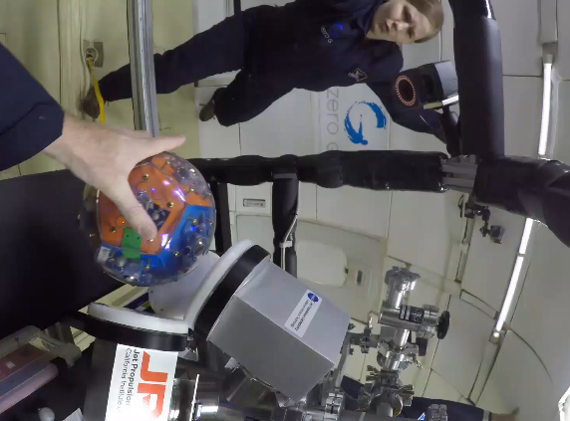
Experiment Validation and Flight Tests
I strongly believe in physically building and testing spacecraft to ensure the validity of a dynamic system architecture. In the span of three years, I’ve constructed three different testbeds for the docking interface, in pursuit of multiple objectives. The first two testbeds were air bearing flat floor testbeds to demonstrate proof-of-concept and to measure high precision 4 degree-of-freedom constrained dynamics. The third testbed was a microgravity testbed to demonstrate and measure 6DOF unconstrained dynamics. The experiments were invaluable in bridging the gap between theory and implementation: revealing key operational obstacles, offering data to develop a more predictive dynamics model, and providing maturity towards spaceflight adoption. An integral part of my research will always include hardware integration and experimentation, aligned with UH Manoa’s commitment to educating a capable aerospace workforce and launching spaceflight missions.
Figure 1: Microgravity flight experiment of flux pinned interface
Estimation and Learning
To convince project engineers to adopt new technologies, a predictive dynamics model is quintessential. Towards this effort, I’ve refined a baseline flux pinning model with countless literature linking model assumptions to empirical data. These refinements and experiment measurements are incorporated into a dual estimator to generate optimal estimates for both dynamic state and physical parameters of the system. To validate the dynamics model, I’ve constructed neural networks to fit a free-form function to measurement data, and will continue this machine learning process by allowing the learner to perturb the system in the loop. I am particularly interested in dispersing many smaller spacecrafts with limited capabilities to an unknown environment. The spacecrafts may share knowledge to detect local phenomena, predict their own and each other’s dynamics, and manipulate the environment. I love to leverage advances in machine learning to aerospace applications, but hesitation lies in the safety of utilizing these black box algorithms in mission critical operations. I wish to bridge the gap between, say, the implementation of neural networks for state prediction and spaceflight implementation by offering verification either during the training process or post-training. Extending this work forward, I also want to extract dynamic information from neural networks to gain insight from the compact representation of the complex system processes. I hope that my efforts may open up to the aerospace industry a tremendous set of machine learning advances in a related but seemingly sequestered field.
In the past, I have been intimately involved with the AFRL for a high agility nanosatellite, NASA Goddard for an innovative star scanner, NASA JPL for the flux-pinned docking interface, and NASA Headquarters as a space technology research fellow. Potential funding sources include NASA’s Innovative Advanced Concept Grants, NASA’s Small Spacecraft Technology Program, AFRL’s Space Vehicles Directorate, DARPA, and NASA internal strategic technology and development collaborations. I plan to create infrastructure (strategic relationships, equipment, and facilities) to quickly bring spacecraft concepts to experimental testbeds, which will support ambitious technological advancements and flight projects.

